Year 9 Quiz 1 Biological Science
Answer Key Score:_____/60
Identify the activity that would be difficult after sustaining damage to the brain stem.
- speech
- walking
- breathing
- intellectual thought

Select the CORRECT statement from below:
- The brain is made up of two hemispheres – right & left cerebellum hemispheres
- The occipital lobe is important in the brain for alertness and sleep modulation
- The axon is an extremely long part of the cell of a neuron and contains dendrites
- Lateralisation is when each half of the brain controls the opposite side of the body

Name two parts of the autonomic nervous system.
- central nervous system and parasympathetic nervous system
- peripheral nervous system and parasympathetic nervous system
- sympathetic nervous system and parasympathetic nervous system
- central nervous system and peripheral nervous system

Listed are the three most important things the Brain needs to function well
A Sleep Drugs Sugar
B Sleep Oxygen Blood flow
C Drugs Sleep Nutrition (food & water)
D Sleep Oxygen Nutrition (food & water)

Select the CORRECT statement from below:
- The frontal lobe is important for higher thinking and intelligence
- The neuron does not contain a nucleus
- Grey Matter surrounds the entire spinal cord
- The sensory neuron is part of a reflex arc that sends messages back to the effector

The cerebellum does NOT control
A body temperature B posture
C co-ordination D balance

Section A— Multiple choice
Instructions: Select ONE correct answer for each multiple choice.

Section B— Short Answer
- ` | a Describe sensory receptors.  - Special organs with nerve endings  - Detect changes in the environment (2)  b What is the function of sensory receptors.  - Collect information  - Convert information to electrical nerve impulse and send to brain/CNS  (2)  c In the TABLE  Label 4 Major types of sensory receptors of the body  and Describe the function of each type of receptor  (4)
  Type of Receptor | Function of receptor type
  Mechanoreceptors | Touch and feeling responses in skin
  Photoreceptors | Are the light sensitive can tell dark & light
  Chemoreceptors | Sensitive to changes in chemicals in body
  Thermoreceptors | Respond to temperature changes in the body
2a Reflex actions are described as involuntary. Explain what this means.
- Happen automatically
- Are not under deliberate control/thinking by brain (2)
2b Label the example of someone touching a hot item
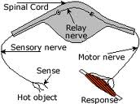
Interneuron

Motor Neuron

Effector

Sensory Neuron

Spinal Cord

Receptor

Sensory Neuron
Interneuron
Motor Neuron
Receptor
Effector
Spinal Cord
(6)

2c, Explain how reflex actions are helpful to people.
- Stimuli are detected quickly
- Travel to Spinal cord and then directly back in reflex arc
- Danger / injury is averted – allow body to react (2)
2d. Match each type of neurons with its function

InterNeurons ______ Pass information from sensory to motor neurons
Motor neurons ______ Move messages to muscles and glands of body
Sensory neurons ___ Collect information from stimuli in sense organs (3)

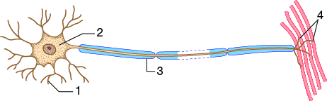
3a Label the neuron
1___Dendrite______________
2___Cell Body_____________
3___Myelin Sheath_________
4___Axon Terminal_________ (4)

3b What is the difference between a neuron and a nerve.
Neuron__a single nerve cell – thin conducts impulse to next neuron
Nerve__Bundle of neurons together which work together to send signals from certain organs (1)

3c What are the two functions of part 3 of the neuron.
- Insulate and protect the axon of the neuron
- Allow for quicker transmission of electrical impulse (2)

Describe the function of each of the following parts of the brain. (8)
Part of brain | Function
Frontal Lobe of Cerebrum | Coordinates thinking and higher intelligent functioning
Cerebellum | Maintains balance, posture, coordination of body
Occipital Lobe | This lobe is involved in processing visual information
White matter | Myelin Sheath covered neurons which move info along spinal cord quickly & help with reflex action
Temporal Lobe of Cerebrum | Responsible for speech and memories
Medulla | Role is to control breathing, heart rate and vital functions.
Pons | Structure located at the base of the brain responsible for manipulating levels of wakefulness, tiredness, sleep response
Corpus Callosum/ Midbrain | Joins left and right hemisphere of brain to each other  Allows movement of neural connection from left & right side of body

5a. A RECEPTOR is a specialised nerve. The receptors main function is
A. Send a message from the brain to the muscles B. Carries out a response
C. Sends message to the central nervous system from an organ D. Detects a stimulus (1)
5b. Select the response that is NOT a reflex
A Sweating on a very hot day B Jumping quickly when you step on sharp object
C Moving hand away from hot object D Blinking when object is thrown at your eyes (1)
5c. Complete the table to describe relationships between stimuli and their receptors.
Stimulus | Receptor | Location
Light | Rod & cones of retina | eye
Chemicals | Taste buds | Mouth/ tongue
Balance | Semicircular canals | In the EAR
Sound | Cochlea cells | In the EAR
(6)

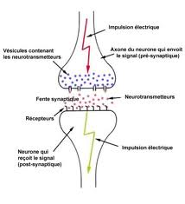
6a. Label the diagram (5)
Neurotransmitter
Synaptic gap
Direction of electrical impulse
Dendrite
Axon Terminal

- Neurotransmitter
- Synaptic gap
- Dendrite
- Axon Terminal
- Direction of electrical impulse

b. Explain what happens at a synapse
- Electrical signal moves down to
axon terminal
- At synapse neurotransmitters are released
into synaptic gap
- The dendrite picks up chemical signal and turns it into new electrical impulse (3)
Colour/shade the parts of the Central nervous System on the Diagram (2)
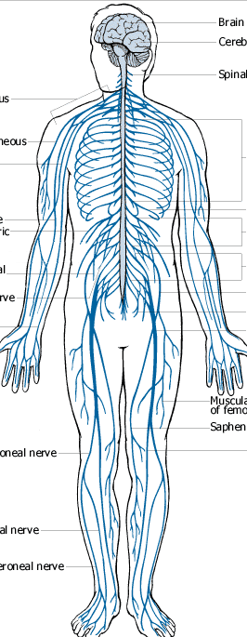
End of Test
Please Check all answers

